

Diploma in Business Informatics

ITP281

E-Business & Project

Business Proposal Report

ITP281-ZC

Team 4

Tan Wei Jun, Terris (172737L)

Elina Ek Pei Shan (173194P)

Cleyshire Cheng Rui Ning (173419K)

Muhammad Adil bin Sabarudin (175476H)

Mr Ong Teck Kiat

**Table of Contents**

**1. Executive Summary**……………………….………………………. 2

**2. Company Overview**……………………….………………………. 3

**3. Product/Service Information**………….…………………………. 4

**4. Value Proposition.**…………………….…………………………… 5

**5. Section on Service Innovation**…….……………………………. 7

5.1. Online Doctor………………...……………………………... 7

5.1.1. About……………………….……….………………………. 7

5.2. Forum…………………………………………...…………… 7

5.2.1. About………………………………………………...………. 8

5.3. Online Shop………………………………………….….…. 8

5.3.1. About……………………………………………………...…. 9

5.4. Complimentary Service Innovations…………………....… 9

**6. Summary**………………………………………………….…………. 10

**7. Appendices**………………………………………….………………. 11

**1. Executive Summary**

**Purpose**

The idea of creating an e-business application is to help solve problems that many young parents face nowadays when they have a newborn. The purpose of this report is to explain how our idea will help to provide a time and money saving service for the busy people in Singapore. We have also conducted a primary research by conducting a survey for young parents and the purpose of our survey was to find out whether parents understand the needs of a newborn.

**Findings and Conclusions**

Our survey results enabled us to find out more about the problems that young parents face with their newborns and their understanding of their newborns. Our survey results show that most of the young parents that we surveyed in Singapore do not have a very strong understanding of their newborns. Also, we found out that parents are also uncertain of the needs of their baby when they fall sick.

**Solution**

Therefore, our idea includes mainly a Forum, 24/7 Online Doctor and an Online Store. All these features will help to provide young parents with a more convenient and efficient platform to communicate and help each other about the problems that they face regarding a newborn. Additional features will also be included in the website to help the company earn profit and facilitate the entire website.

**2. Company Overview**

Our company’s name is ‘Mum’s Story’ and our objective is to provide a platform for young parents to answer enquiries regarding newborns. We are a business-to-consumer website that provides multiple online services for parents with newborns.

Our company aims to provide parents with a more convenient and efficient way to communicate and help each other regarding newborns. Our website consists of mainly a Forum, 24/7 Online Doctor and an Online Store.

The Forum will enable parents to seek help or to help others when other users face a problem with their newborn.

As for the 24/7 Online Doctor, parents can choose to use the service to consult them when they face a minor problem in the middle of the night and when they cannot find a 24/7 neighborhood clinic near their area.

Lastly, the Online Shop allows parents to purchase basic necessities for their baby after getting recommendations from the other users or the online doctor.

We will be making use of the Web-Catalogue Model for our website. Our competitors are ‘Kiasu Parents’, ‘Singapore Motherhood’, ‘Mummy SG’ and ‘Young parents’. Our main sources of profit will be through the sale of our featured products and commission from the 24 hours online doctor service. An additional source of profit is from donations.

3. Product/Service Information

**24/7 Online Doctor**

The 24/7 Online Doctor service is a paid service provided by Mum’s Story. Our Online Doctor services are at a lower price compared to clinics and hospitals. This service works by connecting our customers and doctors to an online face-to-face consultation through Skype, a video calling service. Doctors we hire will have to go through a background check and must be certified by the Singapore Medical Council as we only wish to bring our customers service of the highest quality.

**Online Store**

Our Online Store sells products catered to young parents. They will be able to purchase basic necessities for their baby after getting recommendations from other users or one of the online doctors. We have cut out the middleman, hence our prices are reduced for the benefit of our customers. Despite the low prices, customers can further obtain lower prices by spending points they gain from the reward system for discounts, and also redeeming it for items provided by our sponsors. Therefore, our competitors will be unable to compete with our prices. Items bought from the store will also be delivered to the buyers’ home.

**Forum**

At Mum’s Story, we aim to create a Forum with a community where parents can help one another by contributing ideas on different ways to solve problems faced with their newborns. For example, the different types of milk powder, type of food suitable for their age, tips for raising their child, and much more. Future parents can also study the forum to prepare them and avoid the fear of raising a child. Furthermore, there will be a reward system provided by us to encourage our community members to contribute and stay proactive in the community. The more they contribute to the forum, the more points they gain in our reward system. The points can then be used to get discounts or redeem products on our store.

**4. Value Proposition**

With primary research, we have gathered the following problems faced by our target demographic and presented it in a bar graph.

**The following are some problems parents face:**

Parents are unsure of how to take care of their newborn baby.

With reference from Fig 1, about 60% had neutral understanding of the needs of a newborn baby.

***Fig 1***

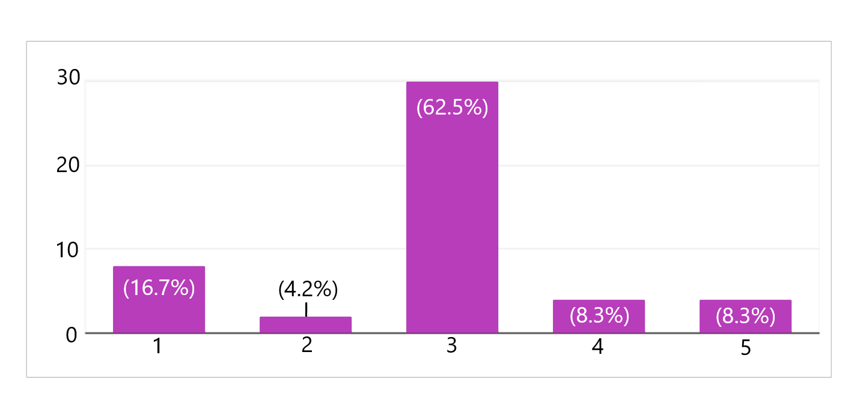

Parents find it a hassle to go down to physical stores to purchase their baby necessities. With reference from Fig 2, half agreed that it was troublesome to purchase baby products physically.

***Fig 2***

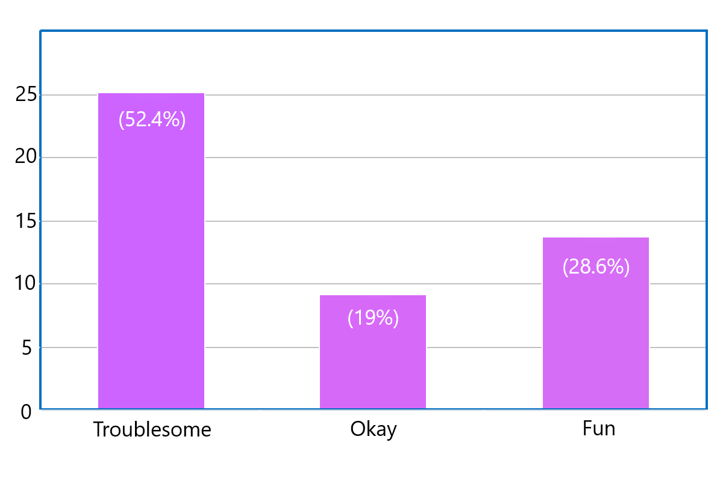

Parents find it a hassle to travel to a clinic to consult a doctor for a simple problem.

With reference from Fig 3, majority also agreed that it was too time consuming to visit a physical clinic.

***Fig 3***



**The following are some benefits to our users:**

* The Forum will help users/parents to seek enquiries.
* Parents can communicate and socialize with each other in the Forum.
* The Online Store enables online purchases, and have it delivered to their doorsteps.
* The 24/7 Online Doctor will help to save a lot of time and trouble for these parents.
* There will be a reward system for users to redeem discounts and products

In conclusion, the Forum, 24/7 Online Doctor, and Online Store will resolve the problems our users face and provide incentive benefits for using our E-Commerce Website.

**5. Section on Service Innovation**

**5.1. 24/7 Online Doctor**

Our idea of having an 24/7 Online Doctor aims to provide parents with an unique experience that offers parents an alternative from the traditional physical clinic approach to suit their wants, such as convenience and affordability.

This idea of a service innovation is our most innovative feature in our proposed E-Commerce Website, Mum’s Story, as it has yet to be popularized in a conventional website, especially by our competitors. With high confidence, we believe that this feature of a service innovation will be the center of attraction of our website.

**5.1.1. About**

The 24/7 Online Doctor is an intermediate platform that connects the user and the doctor together for a consultation session. From there, they will begin their consultation session and charges will be applied based on the duration of the consultation. Both the user and the doctor are required to be logged in and have a Skype account to access this feature.

**5.2. Forum**

The implementation of the Forum will provide many opportunities for our users to bond, create and share experiences with each other. Topics of discussion within the Forum are expected to be oriented around parenting. To prevent exploitations of the Forum, we will also introduce and assign moderators into the Forum section of our website to monitor and act accordingly for any offensive post or comments.

The idea of adding a Forum into an E-Commerce Website aims to embody proactiveness into our users, creating a friendly community where they can communicate and advise each other.

**5.2.1. About**

Within the Forum, users are able to create, view, and comment on to threads posted by other users. An offline-user will be limited to only viewing of threads.

**A logged-in-user will be able to:**

* View threads
* Create threads
* Post comments on threads
* Delete their thread or comment

**Moderators onsite will be able to:**

* Access the features of that of a logged-in-user
* Delete other users’ comment or threads
* Issue warnings
* Restrict other users’ access to certain features in the Forum
* Entitle reward points to logged-in-user

**Senior Moderators onsite will be able to:**

* Access the features of that of a Moderator
* Ban users

Moderators and Senior Moderators will be assigned to employees of Mum’s Story. They will survey the Forum periodically for any offensive post or comments, and act accordingly. They will also entitle reward points based on their own judgement of the usefulness of the comment of users.

A logged-in-user can receive up to 3 warnings. When all 3 warnings have been given, a Senior Moderator will validate the offences they have committed and possibly ban the user’s account, rendering inaccessible.

**5.3. Online Shop**

The Online Store aims to be a platform where our users can shop conveniently for common baby products with the convenience of being at home, displaying an array of items in a form of a web catalogue model. The products sold on Mum’s Story targets baby products, ranging from necessities to milk formula to non-prescribed medication. Users are required to be logged-in to access this feature.

**5.3.1. About**

Within the Online Store, products sold will be of noticeably lower in prices as compared to physical stores in shopping malls due to the cost of production and management being lower on the business perspective. As compared to our online competitors, the service differentiation would be that users will be able to receive reward points to redeem discounts and products, and we will also display products from our sponsors to give users a wider option of products to choose from, making use of their reward points. Online orders made will also be delivered to their homes at a cost of delivery charge. If they spend a minimum of SGD$20, there will be no delivery charge.

**5.4. Complimentary Service Innovations**

In Mum’s Story we also have other services such as a donation page, contact page, profile page, and a reward points system. All these are complimentary services to provide users with more interactivity to our website, if they choose to do so.

**Donation Features:**

* Name display of all donors
* Option to donate
* Total funds raised
* Top donors will be displayed separately

**Contact Features:**

* Address
* Contact numbers
* Frequently Asked Questions
* Attached Hospitals

**Profile Features:**

* Profile customization
* Activity logs
* Edit of details

We will also be utilizing a reward points system where users can earn and accumulate reward points through helping other users on the Forum. Reward points will be assigned by Moderators.

Reward points can then be used to redeem products in the store or get the products at discounted rates depending on the amount of reward points they receive, it can also be used to fully redeem sponsored products for free. Orders with only sponsored products will not have a delivery charge.

**6. Summary**

To conclude, at Mum’s Story, we aim to provide young parents with the full online experience of the digital age of today by bringing in convenience, accessibility, and simplicity onto our E-Commerce Website which enable our users to navigate and use our services with ease.

Besides what our competitors offer, Mum’s Story focuses on tackling the problems parents face when having their newborn. In order to counter these set of problems, we propose an E-Commerce Website that consists of a 24/7 Online Doctor, Forum, Online Store, and complimentary services.

From the business perspective, Mum’s Story will follow the Web-Catalogue Model and profit mainly from our 24/7 Online Doctor and Online Store services.

The purpose of our 24/7 Online Doctor is to enable parents to consult a doctor when they face a problem in the middle of the night, when they cannot find a neighborhood clinic near them. Also, this service will also make it more convenient for them as they do not need to sit through a consultation with physical doctors just to get a medication that was previously prescribed to them.

As for the Online Store, we aim to provide young parents with an ease of purchasing their baby’s necessities online instead of making physical purchases by going down to the physical store to get the products. By having an online store, it allows us to sell directly to our consumers and at the same time, reduce the cost.

The Forum will be a platform where users can socialize and interact with each other. The expected topic of discussions will be centralized towards parenting and users will be highly invoked to stay proactive as they can receive reward points and participate in activities hosted by the community. Moderators will regularly check the state of the forum for any misuse of the forum which will result in them receiving warning from the moderators.

7. Appendices

***Fig 1***



***Fig 2***



***Fig 3***

